**Schedule Management Plan**

**Travel Advisor Web Application**

**v 1.2**

**7/5/2022**

**Table of Contents**

Introduction 3

Milestones 3

Project Schedule 4

Dependencies 5

# Introduction

The project schedule is the roadmap for how the project will be executed. The purpose of the schedule management plan is to define the approach the project team will use in creating the project schedule. to show the team how they will monitor the project schedule and manage changes after the baseline schedule has been approved. This includes identifying, analyzing, documenting, prioritizing, approving or rejecting, and publishing all schedule-related changes.

# Milestones

The milestones will be delivered four times, each one will be delivered at the end of the week based on determinates that we take from the customer, and at the final we will deliver the final milestone that include the project phases from the initiation till the closing of the project.

Table 1 Milestone-1

|  |  |  |  |  |
| --- | --- | --- | --- | --- |
| Milestone | Date | Status | Responsibilities | Issues/Comments |
| SIQ | 12/4/2022 | Completed | Ashry, Aya, Medhat, Saad, Nada | N/A |
| SRS | 13/4/2022 | Completed | Aya, Ashry, Medhat | N/A |
| Project Charter | 13/4/2022 | Completed | Saad | N/A |
| PMP | 14/4/2022 | Completed | Nada, Saad | N/A |
| CM Tool up | 10/4/2022 | Completed | Saad | N/A |
| Schedule | 14/4/2022 | Completed | Nada | N/A |

Table 2-Milestone 2

|  |  |  |  |  |
| --- | --- | --- | --- | --- |
| Milestone | Date | Status | Responsibilities | Issues/Comments |
| SRS after modifications | 29/4/2022 | Completed | Medhat, Saad | N/A |
| Wireframe | 29/4/2022 | Completed | Aya | N/A |
| Sequence Diagram | 29/4/2022 | Completed | Nada | N/A |
| Use-Case Diagram | 29/4/2022 | Completed | Ashry | N/A |
| ERD Diagrams | 29/4/2022 | Completed | Saad | N/A |

# Project Schedule

The project schedule will be reviewed and updated as necessary on a bi-weekly basis with actual start, actual finish, and completion percentages which will be provided by task owners.

The project manager is responsible for holding bi-weekly schedule updates/reviews; determining impacts of schedule variances; submitting schedule change requests; and reporting schedule status in accordance with the project’s communications plan.

The project team is responsible for participating in bi-weekly schedule updates/reviews; communicating any changes to actual start/finish dates to the project manager; and participating in schedule variance resolution activities as needed.

# Dependencies

If any member of the project team determines that a change to the schedule is necessary, the project manager and team will meet to review and evaluate the change. The project manager and project team must determine which tasks will be impacted, variance as a result of the potential change, and any alternatives or variance resolution activities they may employ to see how they would affect the scope, schedule, and resources. If, after this evaluation is complete, the project manager determines that any change will exceed the established boundary conditions, then a schedule change request must be submitted.

Submittal of a schedule change request to the project sponsor for approval is required if either of the two following conditions is true:

* The proposed change is estimated to reduce the duration of an individual work package by 10% or more, or increase the duration of an individual work package by 10% or more.
* The change is estimated to reduce the duration of the overall baseline schedule by 10% or more, or increase the duration of the overall baseline schedule by 10% or more.

Any change requests that do not meet these thresholds may be submitted to the project manager for approval.

Once the change request has been reviewed and approved the project manager is responsible for adjusting the schedule and communicating all changes and impacts to the project team, project sponsor, and stakeholders. The project manager must also ensure that all change requests are archived in the project records repositor. So, we proposed in this Schedule Management Plan our schedule in this project and the dependencies between those tasks and between each other.

For more clarification, this figure show the dependencies between the phases in our project.

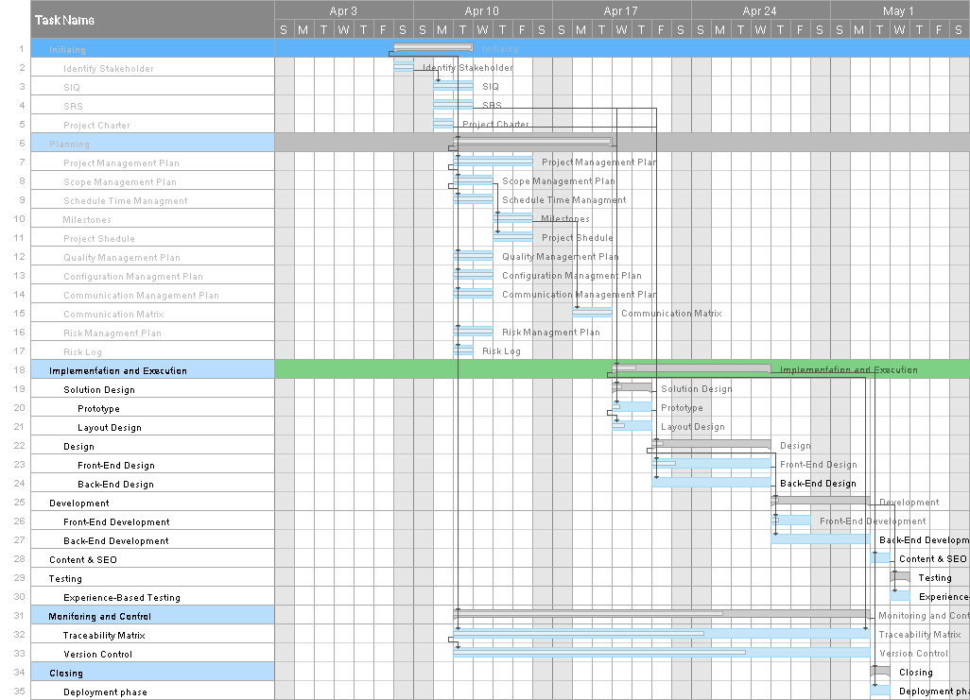

Figure 2-Gantt Chart